**Changes Made to Milestone 1**

1. Added in second round of questions
2. Added in second round of affinity diagramming
3. Added in second round of interview transcripts
4. Added in demographics to User Demographics
5. Added method for gathering/sampling users in methodology for data collection
6. Added second round to user summary
7. Added summations to the conclusion and future plans

After reviewing feedback from our initial submission of Milestone 1, we recognized a few issues with our initial methodology. To that end, we’ve made a few changes to the scope of the project, as you can see below. Firstly, in our initial submission we made reference to revising the whole of the WebSTAC system, not just the registration portion as focused upon in the project pitch. We have decided to scale back our aspirations back to better match the original pitch, and focus on creating a course registration system for users.

Due to a combination of this change in focus, as well as a realization that our initial interview methodology was inadequate, we went and conducted additional interviews to better match our new goals. Where the first round of interviews resulted in feedback about the existing WebSTAC (which, while enlightening, doesn’t necessarily assist us in creating our own system), the second round of questioning was geared towards understanding the thought process of various students during registration in an attempt to conceptualize a system best suited to their needs. It should be noted that our previous round of sampling also featured a heavy bias towards upperclassmen and students within the engineering department. The subsequent round of sampling featured a much more rounded pool of interviewees, with respect to the two elements that we believed to be the main focus: college level and university college. The finer points of these demographics are discussed in the main body of the paper.

The newest interviews gave us a much better insight into the thought process of a variety of students as they approach the registration process, as opposed to simply what they found wrong with the WebSTAC system. These interviews revealed that during the mental process of choosing classes, there are several categories of priorities, which often vary depending on the age of the student or their career path. These insights are elaborated upon below.

**Milestone 1 Writeup**

**Data Source and Representativeness**

Each team member interviewed three to four different interviewees currently attending Wash U, giving a total of 28 interview transcripts to extract data from. The interviewee pool contains graduate and undergraduate students of all class years except freshman.

* In the second round of data collection, we conducted 11 additional interviews with brand new designed questions to better capture user behavior/thought process in course registration and hence understanding the system requirements from the perspective of users task needs. The interviewees in this round of interviewing are not only engineering school students or most graduate students.

Even though the first round of interview generates a broader feedback on the whole WebSTAC system, we still have some response directly related to the course registration portion of the website. Therefore, combining the two rounds of interviews, we believe the data is a representative sample of the target audience.

Even though the number of users participating in the interviews is small (39) compared to the actual population of users of the WebSTAC system, we still obtained a large amount of redundant responses in the first round of interviews. Yet, the purpose of the registration is very clear and straightforward, the user process is very similar (focusing one or two particular aspect of the course information) with little deviation from the regular routine in the second round of the interview. Therefore we believe we hit diminishing returns.

**Methodology for Data Collection**

The method we used to gather data was questions-and-answer style interviews with the questions prepared ahead by the team. This approach is effective as we directly captured interviewees’ responses and emotions by talking to them face to face. Moreover, besides prepared questions we also asked a few follow up questions that were totally dependent on the interviewees’ response.

The master sheet of detailed interview questions can be found in the *WebSTAC User Summary* section. To conduct the first round of interviews we split up and conducted the interviews independently. We focused primarily on students in our classes or near us, which lead to our sampling pool being primarily engineering graduate students.

* For our second round of interviewing we tried to prevent this same bias by trying to gather a much more random sample of students on campus. To do this we paired up and conducted our interviews of students that were at the DUC and at Einstein's Bagels in the Business school. We approached students and asked if they had time to answer a few questions and if they did we had one person record the conversation and another ask the questions. The person asking questions ensured the interview was made up of the prepared questions, and the recorder added in additional questions that they felt would either clarify the answer or gain more information from a user.
* The first round of interview questions is prone to the negative bias as we asked many subjective questions regarding the user experience. In the second round of the interview, we redesigned the questions with the purpose of understanding how users or potential users use webSTAC for course registration, and therefore the questions we newly come up are neutral and directly captures the user behavior process.

Additionally, when new insights/responses were given, we asked non-prepared questions to follow up with the interviewees’ answers. This choice positively impacted our data collection by allowing us to gather additional details.

**Data Quality**

After conducting the interviews, we obtained 28+11 transcripts which are attached at the end of this document. The data is in the form of pure text and it contains information that reflects which aspects of WebSTAC can be improved. While we did observe the interviewees’ facial expression, gestures, etc, we did not include such details in our transcripts as the sentiments can be easily extracted from their responses.

**WebSTAC User Summary**

**Data From Round One**

**Reasons for visiting WebSTAC:** Our interviews reveal a series of reasons that users chose to visit the site:

* Paying bills or adding money to Bear Bucks account
* Using WUAchieve to determine degree progress
* Register for classes or to view course catalogs
* Check current class schedule
  + Also shows required textbooks, building locations
* Change password and other user details
* Using links on site to access other services, such as housing and email

The most common usage of WebSTAC is to register for classes and to view the online course catalog. This did not come as a surprise, as it is a feature that every student must perform at least once every semester. Something that did come as a bit of a surprise was the use of WebSTAC in order to access other services. Some interviewees discussed logging into WebSTAC only to follow the link to view their university email.

**Opinions of WebSTAC Feature Set:** The interviewees revealed their opinions on the current status of WebSTAC’s features.

* WebSTAC should only be for administrative purposes, and shouldn’t try to take the place of BlackBoard or Canvas.
  + Registration, financial issues, user info
* There are some features that are considered useless or obsolete

Many users described WebSTAC with a bit of ambivalence, while they admit that the site has its issues, they use it seldom enough that it doesn’t bother them too much. Some users did describe how the abundance of features causes the site to become cluttered, namely on the main landing page and in the drop down menus. Several agreed that the main page could be utilized better, while others were unphased by any unrequired features.

**Mobile App:** Several students specified their usage of the mobile app as their primary means of access:

* Unresponsive design, some features don’t work under certain orientations
* The university themselves advocates not using the mobile app for anything vital
* Housing portal is much less useful with recent updates
* Username/password cannot be remembered

In comparison to the desktop experience, users expressed a much more negative experience with the mobile counterpart. While the desktop site complaints were categorized as mere annoyances, the mobile app was noted to have several broken or ineffective features, such as the map view or housing portal. The overall UI was also considered to be poor and inconsistent.

**In comparison to other services:** Some students have attended other schools with a similar system and provided their insight:

* Registration system requires more page navigation
* Much worse ability to plan schedule in the long-term
* Despite its faults, some services are much worse

The main opinion that seemed to be shared amongst interviewees who had been exposed to a similar system was that WebSTAC seems roughly on par with those services, however those other services were considered to have some faults as well. The differences in the registration experience were the most noted, with WebSTAC being considered more convoluted to use and more difficult to plan out a long-term degree plan.

**Opinions on overall aesthetics:** Users provided comments on how effective the aesthetics of the UI were to them:

* Alerts/notifications are difficult to notice
* Overall is plain and ugly in appearance
* Should be less complex and more performant
* Feels too cluttered

The most common complaint about the website’s appearance was simply the statement “it’s ugly”. Specifically, several mentioned that parts of the page, including the main landing page had too much clutter on it with features deemed useless, such as WebSTAC update news. Many also expressed that while they had some complaints, there wasn’t an obvious issue that stuck out to them as a vital negative component.   
  
**Opinions on Registration:** Users gave ideas on how to make registering for classes more effective and intuitive:

* Registration worksheet only requiring one page
* Auto-register for classes
* Using the grid view instead of the list view as a default
* Search Bar needs to find classes more efficiently
* Students shouldn’t have to know full listing to search for a class
* Class listings should include reviews, history, and syllabus

The interviews were not aimed at solely the registration portion of WebSTAC. We thought it more important to understand user’s frustrations with the whole site rather than just the registration portion. However, the user’s frustrations with the registration site surfaced. The focus of most of these interviews was how the registration worksheet, the class listings, and the actual registration aren’t on the same page. They find that multiple pages make finding classes really difficult. Users also said that the search function is very difficult to use, and often requires almost close to the full course listing to achieve any results. There was also an emphasis on the gridview being the best option for the registration site.

**Indifference on Site:** Surprisingly, there was a lot of indifference from the users about improving the site. Their comments were about the following:

* Meets their needs
* Unused functions/links don’t really affect them
* Typically neutral experiences
* Plain but simple

A lot of users expressed an indifference to the site. The site does what they need it to, and while they don’t describe it as pretty or uncluttered it does everything that it needs to. Users did note that they did not use many of the offered features, but that doesn’t affect their use.

**Opinions of WUAchieve:** Users described WUAchieve as the following:

* Does not update properly
* Can’t test fields
* Only thing they use on WebSTAC
* Doesn’t reflect current progress

When users expressed opinions about WebSTAC it was either that it is very helpful, or that it isn’t updating properly. The users that like WUAchieve really like it, and use it frequently, but the users that don’t find it very difficult and would like something that provides more specific requirements for students.

**Data From Round Two**

**Users don’t plan out more than a semester in advanced:** We found that many students don’t plan out their four or more years at WashU at a time, and frequently were only planning out semester by semester. Students gave reasoning for this, but most being that the course listings are really only offered semester by semester.

**Students choose course descriptions that sound the best:** Many of the students we interviewed said that they read the course descriptions in depth, and most said that is how they pick their courses, specially the ones that are not requirements for their major. Some commented on taking classes just because the course description sounded fun.

**The Professor, and their reputation matter to students picking classes:** Almost all of the students sampled mentioned that they often picked the classes based on the professor teaching. Some said that they might delay taking a class if the professor wasn’t well liked. One student said that the professor might be the most important part.

**Students look to other students to gain perspective on classes and professors:** All of the students emphasized that they research and pick classes based on other students opinions and experiences. Only one student said that their friends aren’t helpful because they aren’t in the same major, but a few expressed how their friends might know someone who can get them the same information. Word of mouth recommendations really were emphasized as the most common way to research classes.

**RateMyProfessor is helpful, but only as a backup:** A lot of students mentioned looking at RateMyProfessor to see professors’ reputations in the past. The students that mentioned using this site was only used when they have picked a course and are deciding between two professors. One student said it was very outdated for the professors in their department.

**Class size plays a role in picking classes:** Some students mentioned that they pick classes that have smaller class sizes. They mentioned that sometimes you can’t get away from taking a larger class, but for their electives they prefer to take smaller classes so they can have a better experience in the class.

**Students have developed other ways to plan out a semester:** Students gave the following ways to plan registration

* Google sheets for each year
* SOAR
* Pen and paper
* ANS planet

Students gave many ways that they used to plan out which classes they are going to take for the current and future semesters. Interestingly, none of them mentioned using WebSTAC’s registration worksheet.

**Advisors opinions matter to students choosing classes:** A lot of students expressed that they talk to their advisors about which classes they need to take. Many students mentioned use their advisors opinions about requirements, but the students didn’t seem to mention using the opinions of their advisors for much else.

**User Demographics:**  In the first round of questions our sample users were made up of 1 first year (or similar), 1 sophomore, 2 juniors, 3 seniors (including one fifth year), and 9 graduate students. The majority of these students came from the school of engineering, which creates a lot of bias in our data when you consider that every college on campus uses webstac. In our second round of questions we had 4 first years, 1 sophomore, 4 juniors, and 1 senior. As far as sampling among the different schools we had 5 students from Arts and Sciences, 2 students from Olin Business school, 1 in Education, 1 in Engineering, and 1 undeclared student. We believe that the second round of questioning did improve the distribution across the two parameters we believe to be the most noteworthy: year and which university school they’re in. However, it should be noted that while our distribution has improved, there are some areas that could require greater representation, sophomore level students are one notable example, as well as students from some of the other schools, like law or architecture. However, we feel confident that the range of students we interviewed provided with enough berth of information to make accurate progress going forwards.

**Methods**

Our interview process was to ask WebSTAC users the following questions.

1. What are the most three items you think highly of?
2. What are the most three struggling items when using the WebSTAC?
3. When was your last time to use the WebSTAC, and how do you think your experience? (you can say anything pro/con you want)
4. Is there a website has similar functionalities with the WebSTAC that you has used before? And what do you think of it by comparing with the WebSTAC?
5. What are most three functions that you desire?
6. Under what circumstances do you visit WebSTAC?
7. Is there an example of WebSTAC having a feature that was surprisingly/particularly useful (possibly reword this). Was there an example of the site not meeting your expectations?
8. What is something that the website doesn’t do (or doesn’t do well) that you wish it would?
9. If you could change one thing about WebSTAC, what would it be?
10. Are there features on other similar services that you wish were in WebSTAC?

**In a second round of interviews we asked the following questions.**

1. What is your name?
2. What is your school/major?
3. What year are you?
4. What do you consider when choosing courses for the next semester?
5. What information about a course makes you interested in taking it?
6. Do you talk to anyone about registration?
7. How far ahead do you plan out your courses?
8. Do you ask for course recommendations from other people? How heavily do you follow their advice?

To organize and make sense of our interview data we decided to use an online tool called Trello that allows you to make different boards and move things around. Typically this is used for groups working on projects or teams using some type of agile workflow, but it worked well for affinity diagramming as well because it allows you to move cards in different columns and reorganize and data however much you want. It was a great way for us to visualize all the interviews without creating a lot of waste. Pictures of the affinity diagram and a link to our trello site are below.

**Conclusion**

WebSTAC is a service that every single student enrolled at WashU has to use on a somewhat regular basis, and like any multi-purpose administration tool, there are a wide variety of opinions on its effectiveness. From our interviews, the general consensus seems to be a negative one, with users mainly highlighting the visual appeal, feature bloat, and ease of use as the main issues with the site. It is worth noting however, that users were not opposed to the idea of WebSTAC or what it offered. In fact, it seems that for most of the features it offers, the requested solution is to reorganize the site structure to emphasize currently available features and to remove some of the cruft of antiquated features still in the system.

From the feedback we have received thus far, the priorities going forward focus around two or three main ideas. Perhaps the most prominent of which being the appearance and performance of the site. While WebSTAC may have been an appealing site back upon its introduction, modern web UI design has moved on, and WebSTAC has not followed suit in these new design fundamentals. In addition, while the site seems to be rather barebones in its physical appearance, its performance was negatively remarked upon as well.

Interviews also noted the difficulties in navigation, even by well-experienced users attempting to locate commonly used items. A number of features that have either become antiquated or viewed by students as unnecessary prevent easy access to the core list of most used site features.

Also worth noting are the complaints to the mobile app version of the site. These criticisms seemed much greater in comparison, mainly aimed at the overall functionality of its services. Due to the nature of the project, recreating the mobile app version of the website it likely beyond our scope, however it may be worth looking into an interface that scales well to both desktop and mobile usage. This may prove difficult, due to the existence of features more commonly utilized via a mobile app vs a desktop experience and vice versa.

Interviews also emphasized the importance of what information students useful in searching for classes. It seems like many students make decisions on what courses to take based on the recommendations of others. The course listing, reputation, professor, and timing of a class are all important to students, but not all of this information is accessed on WebSTAC. Integrating previous course reviews with the course listings, or creating our own recommendation system might make searching for classes an easier process for students.

**Future Plans**

**Following Round One**

Based on the information we collected from our interviews, we have decided to focus on redesigning the registration portion of WebSTAC. A majority of interviewed users desired a single page registration sheet with a more effective search field. There was an emphasis on using the grid view over the list view as default. Users also had suggestions on how to make the course listing more informative; for example introducing previous reviews, grade distribution, and the ability to view students taking the class. While there were suggestions about how to improve the phone application and the main page; users were more indifferent on these as a whole, focusing instead to talk about improvements to several key features of the registration site. To best serve the users we feel that focusing on redesigning user interactions with the core functionalities of the site is the best focus for the project going forward.

**Following Round Two**

After conducting an additional round of interviews, we felt the need to revise some of our plans going forward. While many of us are most familiar with WebSTAC, it should not form the basis of our plans going forward. Instead, we wish to focus our efforts on our own, unique registration system. By addressing the things that users require most, we will inherently remedy some of the most commented upon issues of WebSTAC. To that end, we have noticed that what users seem to value the most is a variety of information regarding perspective courses, tools to plan out their long term plans and their required course work, and a way to view feedback from previous students. It is upon these points that we feel we should focus our efforts.

**Raw data**

**First Round of Affinity Diagramming**

Link to Trello Board: <https://trello.com/b/JpaYDZKr/affinity-diagram>. This is the place we did the affinity diagramming

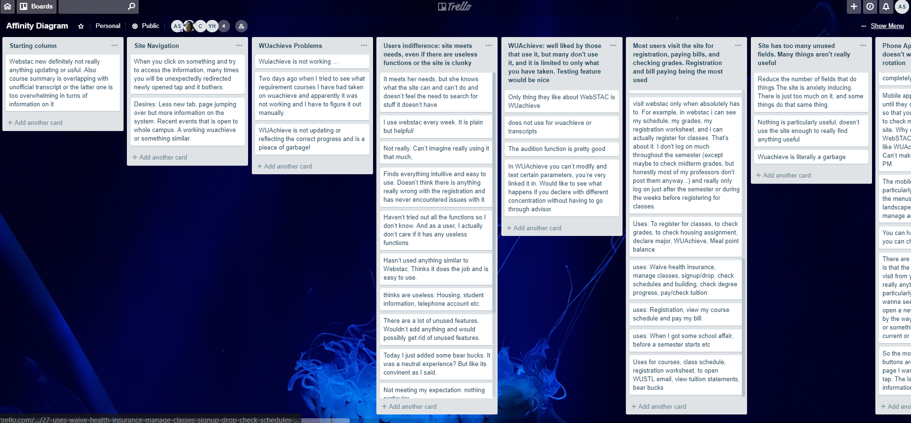

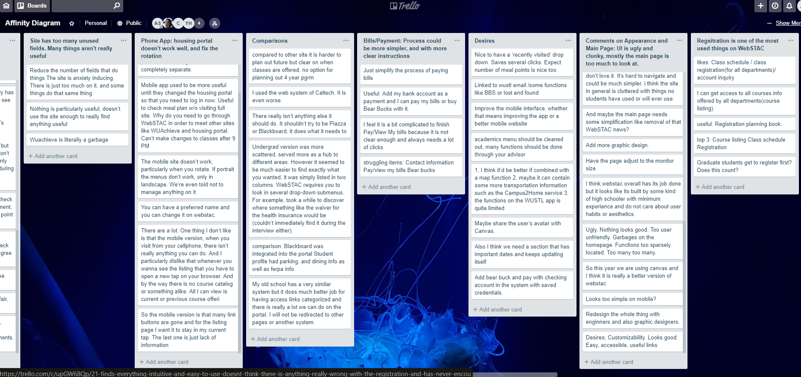

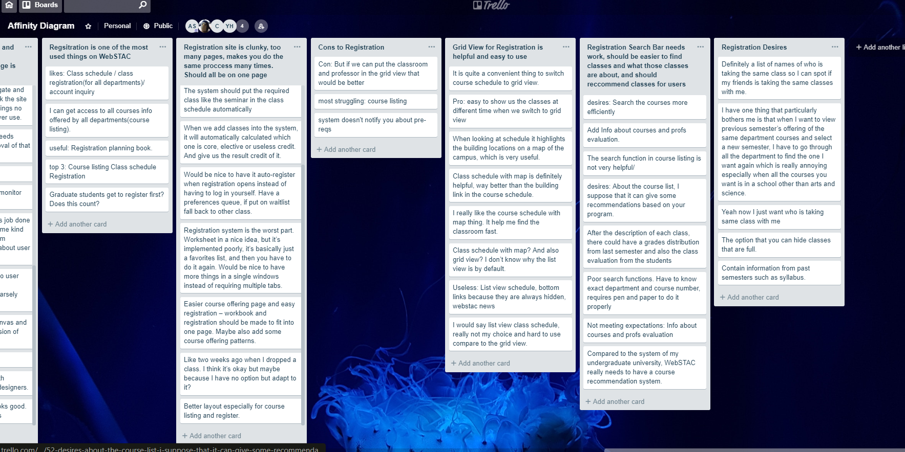

**Second Round of Affinity Diagramming**

Link to Trello Board: <https://trello.com/b/uc2UTTp9/milestone-one-redux>

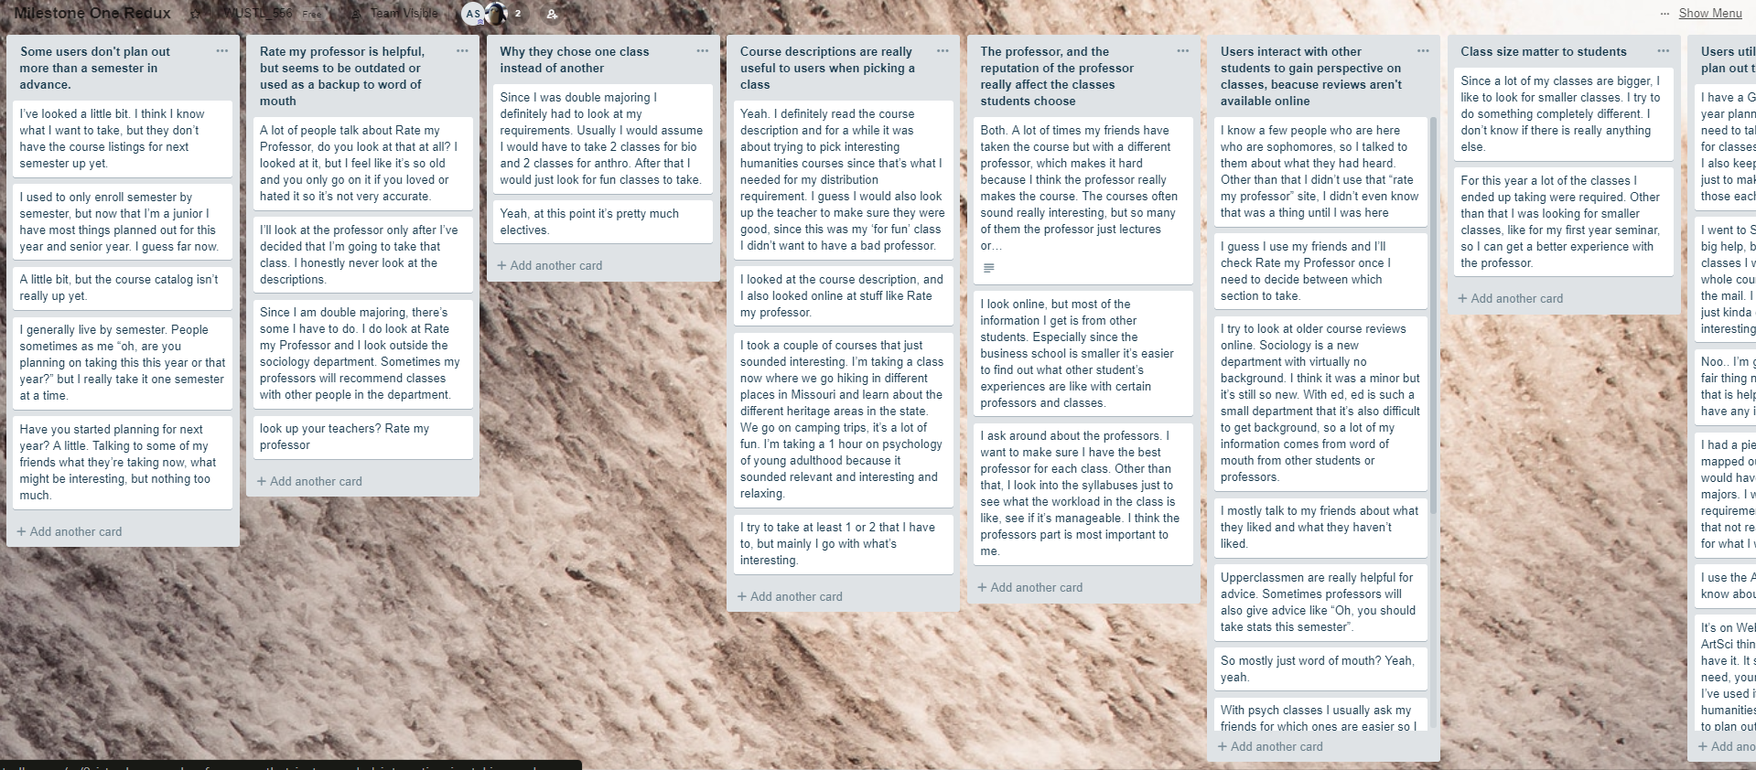

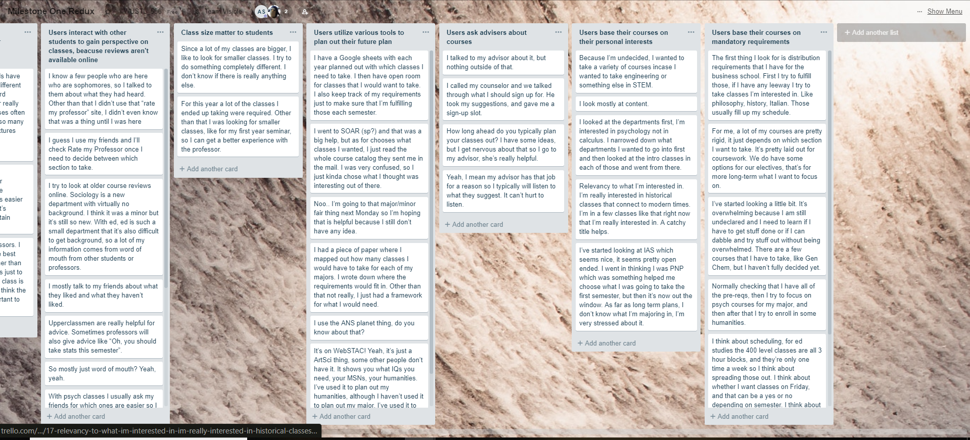

**Interview Transcripts**

**First Round of Questions**

Interviewer: Austin Bricker

Interviewee: Taylor Herald

Years at WashU: Grad student - 2 full years

1. To sign up for courses, view current class schedule, prepare for next semester with registration worksheet, to open WUSTL email, view tuition statements, very rarely the WUachieve or unofficial transcript, use link to bear bucks
2. Pleased with WUachieve, probably the only thing he likes about WebSTAC. Throwing too much irrelevant information about the site on the main page.
3. Specifically doesn’t like main page. It shows schedule but not professors, classes, time/date, etc. Instead shows news. Shows drop deadlines which many don’t necessarily need.
4. Change Academics menu to just WUAchieve, intent to graduate, Unofficial transcripts, order transcripts. The others are too particular and should be done through your advisor.
5. Compared to undergrad university, it was much clearer which classes were being offered each semester. Much harder to plan out the future. At old school were able to plan out entire 4 year program, can’t do that here. Would like to be able to specify start and end date and make it clearer to see available catalog and plan out farther in the future. This system doesn’t notify you about pre-reqs at all.

Interviewer: Austin Bricker

Interviewee: Amelia Delzell

Years at WashU: 2 full years

1. To register for classes, to check grades, to check housing assignment, declare major, WUAchieve, Meal point balance
2. Mobile app used to be more useful until they changed the housing portal so that you need to log in now. Useful to check meal plan w/o visiting full site. Why do you need to go through WebSTAC in order to meet other sites like WUAchieve and housing portal. Can’t make changes to classes after 9 PM.
3. It meets her needs, but she knows what the site can and can’t do and doesn’t feel the need to search for stuff it doesn’t have.
4. The housing portal. It used to all be on WebSTAC, then it was moved and doesn’t work on phone. Either merge them or completely separate.
5. Wishes that there weren’t so many pages for registration. Having to view catalog, and registration worksheet, and then actual registration. Poor search functions. Have to know exact department and course number, requires pen and paper to do it properly.

Interviewer: Austin Bricker

Interviewee: Jason Christal

Years at WashU: 2 full years

1. WUAchieve, grades, registration, looking at course listings, meal point balance, loading Bear Bucks, housing portal for mailbox code
2. Nice to have a ‘recently visited’ drop down. Saves several clicks. Expect number of meal points is nice too. In WUAchieve you can’t modify and test certain parameters, you’re very linked it in. Would like to see what happens if you declare with different concentration without having to go through advisor.
3. Registration system is the worst part. Worksheet in a nice idea, but it’s implemented poorly, it’s basically just a favorites list, and then you have to do it again. Would be nice to have more things in a single windows instead of requiring multiple tabs.
4. See above, the issues with the registration, in the past have registered for wrong section without realizing. Would be nice to have it auto-register when registration opens instead of having to log in yourself. Have a preferences queue, if put on waitlist fall back to other class.
5. Haven’t experienced any others. For the most part it’s fine. A bit ugly.

Interviewer: Amelia Santrach

Interviewee: Capri

Years at WashU: 4 years and graduating this year

1. Registration, wuachieve, paying bills, but mostly just uses for registration
   1. Only uses the app to check where the shuttle is
2. Nothing is particularly useful, doesn’t use the site enough to really find anything useful
3. Finds everything intuitive and easy to use. Doesn’t think there is anything really wrong with the registration and has never encountered issues with it.
4. There are a lot of unused features. Wouldn’t add anything and would possibly get rid of unused features.
5. Hasn’t used anything similar to Webstac. Thinks it does the job and is easy to use.

Interviewer: Amelia

Interviewee: Robin Linzmayer

Years at WashU: 5

Q1. What reasons do you visit WebSTAC over other sites WashU provides? When do you typically do this? Are there features that you find particularly useful?

1. i visit webstac only when i absolutely have to. For example, in webstac i can see my schedule, my grades, my registration worksheet, and i can actually register for classes. That's about it. I don't log on much throughout the semester (except maybe to check midterm grades, but honestly most of my professors don't post them anyway...) and really only log on just after the semester or during the weeks before registering for classes.

Q2. Can you think of a time when WebSTAC didn't meet your needs, or you left the site without accomplishing your goal?

2. Webstac is gross to look at. Also it took two years to figure out i could see my GPA and to really understand how to navigate the page

Q3. What frustrates you most about the site?

3. Nothing frustrates me specifically i just don't love it. It's hard to navigate and could be much simpler. i think the site in general is cluttered with things no students have used or will ever use.

Q4. Have you used any other services, maybe at another school, or a similar kind of site that you find more intuitive or user friendly? What are the differences between WebSTAC and this site?

4. Nope

Interviewer: Austin Bricker

Interviewee: Griffin Shaw

Years at WashU: 1 full year

1. Waive health insurance, manage classes, signup/drop, check schedules and building, check degree progress, pay/check tuition
2. When looking at schedule it highlights the building locations on a map of the campus, which is very useful. The mobile site doesn’t work, particularly when you rotate. If portrait the menus don’t work, only in landscape. We’re even told not to manage anything on it.
3. There really isn’t anything else it should do. It shouldn’t try to be Piazza or Blackboard, it does what it needs to.
4. Improve the mobile interface, whether that means improving the app or a better mobile website.
5. Undergrad version was more scattered, served more as a hub to different areas. However it seemed to be much easier to find exactly what you wanted, it was simply listed in two columns. WebSTAC requires you to look in several drop-down submenus. For example, took a while to discover where something like the waiver for the health insurance would be (couldn’t immediately find it during the interview either).

Interviewer: Yunshen Huang

Interviewee: Zongyi Li

Years at WashU: Undergraduate, 3 full years

Old webSTAC system

1 What are the most three items you think highly of?

○ Registration Worksheet, grade, mealpoint,

2 What are the most three struggling items when using the webSTAC?

○ course listing

3 When was your last time to use the webSTAC, and how do you think your experience? (you can say anything pro/con you want)

○ I use webstac every week. It is plain but helpful/

4 Is there a website has similar functionalities with the webSTAC that you has used before? And what do you think of it by comparing with the webSTAC?

○ I used the web system of Caltech. It is even worse.

New webSTAC system

5 What are most three functions that you desire?

○ Search the courses more efficiently

6 What are most three functions that you think are useless for a website like webSTAC

○ Housing, student information, telephone account etc.

1. Under what circumstances do you visit WebSTAC?

a. When I want to check my schedule or meal point balance. Also registration in the beginning of each semester.

2. Is there an example of WebSTAC having a feature that was surprisingly/particularly useful (possibly reword this). Was there an example of the site not meeting your expectations?

a. The audition function is pretty good

b. The search function in course listing is not very helpful/

3. What is something that the website doesn’t do (or doesn’t do well) that you wish it would?

4. If you could change one thing about WebSTAC, what would it be?

a. Make the website simpler and faster.

Are there features on other similar services that you wish were in WebSTAC?

Interviewer: Yunshen Huang

Interviewee: Chenjie Gao

Years at WashU: Graduate, first years

Old webSTAC system

● What are the most three items you think highly of?

1, WebSTAC accounts are connected with other systems like Canvas, Office 365

2, I really like the view/pay my bill function which can show me my bills clearly

3, I can see the details of each course including the schedule and textbooks it requires.

● What are the most three struggling items when using the webSTAC?

1, I think it’d be better if combined with a map function

2, maybe it can contain some more transportation information such as the Campus2Home service

3, the functions on the WUSTL app is quite limited

● When was your last time to use the webSTAC, and how do you think your experience? (you can say anything pro/con you want)

Last week, to inquire my Bear Buck account. It’s convenient IMO especially on the WUSTL app.

● Is there a website has similar functionalities with the webSTAC that you has used before? And what do you think of it by comparing with the webSTAC?

Nope

New webSTAC system

● What are most three functions that you desire?

Pls refer to Q2

● What are most three functions that you think are useless for a website like webSTAC?

Haven’t tried out all the functions so I don’t know. And as a user, I actually don’t care if it has any useless functions.

1. Under what circumstances do you visit WebSTAC?

When I got some school affair, before a semester starts etc.

2. Is there an example of WebSTAC having a feature that was surprisingly/particularly useful (possibly reword this). Was there an example of the site not meeting your expectations?

Useful: Add my bank account as a payment and I can pay my bills or buy Bear Bucks with it.

Not meeting my expectation: nothing particular

3. What is something that the website doesn’t do (or doesn’t do well) that you wish it would?

Pls refer to Q2

4. If you could change one thing about WebSTAC, what would it be?

Maybe share the user’s avatar with Canvas.

5. Are there features on other similar services that you wish were in WebSTAC?

Nothing particular.

Interviewer: Yunshen Huang

Interviewee: Yifu Wang

Years at WashU: graduate, 1 full year

1. Registration, view my course schedule and pay my bill.
2. It is quite a convenient thing to switch course schedule to grid view. I feel it is a bit complicated to finish Pay/View My bills because it is not clear enough and always needs a lot of clicks.
3. About the course list, I suppose that it can give some recommendations based on your program.
4. Just simplify the process of paying bills.
5. Compared to the system of my undergraduate university, WebSTAC really needs to have a course recommendation system. And maybe the main page needs some simplification like removal of that WebSTAC news?

Interviewer: Yunshen Huang

Interviewee: Yannan Gao

Years at WashU: graduate, first year

Old webSTAC system

● What are the most three items you think highly of?

Class schedule / class registration(for all departments)/ account inquiry

● What are the most three struggling items when using the webSTAC?

Bad layout / password cannot be remembered on the app version of webSTAC/ the personal info displayed on the home page/hard to register a course

● When was your last time to use the webSTAC, and how do you think your experience? (you can say anything pro/con you want)

09/19/2018 / It was a bad experience…Same as above.

● Is there a website has similar functionalities with the webSTAC that you has used before? And what do you think of it by comparing with the webSTAC?

No, I haven’t used any similar website before

New webSTAC system

● What are most three functions that you desire?

More beautiful layout/ An special app developed for webSTAC on telephone/ Some functions like BBS

● What are most three functions that you think are useless for a website like webSTAC

Housing info/ my photo appears in the home page/

1. Under what circumstances do you visit WebSTAC?

Check the class schedule and register courses.

2. Is there an example of WebSTAC having a feature that was surprisingly/particularly useful (possibly reword this). Was there an example of the site not meeting your expectations?

I can get access to all courses info offered by all departments(course listing).

Not meeting: Info about courses and profs evaluation.

3. What is something that the website doesn’t do (or doesn’t do well) that you wish it would?

Better layout especially for course listing and register.

4. If you could change one thing about WebSTAC, what would it be?

Add Info about courses and profs evaluation.

5. Are there features on other similar services that you wish were in WebSTAC?

Linked to wustl email /some functions like BBS or lost and found

Interviewer: Yunshen Huang

Interviewee: Fangying Zhai

Years at WashU: graduate, 1 full year

Old webSTAC system

● What are the most three items you think highly of?

Course listing

Class schedule

Registration

● What are the most three struggling items when using the webSTAC?

Contact information

Pay/view my bills

Bear bucks

● When was your last time to use the webSTAC, and how do you think your experience? (you can say anything pro/con you want)

Last week to check the class schedule

Pro: easy to show us the classes at different time when we switch to grid view

Con: But if we can put the classroom and professor in the grid view that would be better

● Is there a website has similar functionalities with the webSTAC that you has used before? And what do you think of it by comparing with the webSTAC?

Usually, if there is some alerts, they will show it more obviously

New webSTAC system

● What are most three functions that you desire?

1. When we add classes into the system, it will automatically calculated which one is core, elective or useless credit. And give us the result credit of it.

2. After the description of each class, there could have a grades distribution from last semester and also the class evaluation from the students

3. The system should put the required class like the seminar in the class schedule automatically

● What are most three functions that you think are useless for a website like webSTAC

Faces, Telephone account detail, Verification

1. Under what circumstances do you visit WebSTAC?

Check class schedule

Registration

Change password

Course listing

Pay/view my bill

2. Is there an example of WebSTAC having a feature that was surprisingly/particularly useful (possibly reword this). Was there an example of the site not meeting your expectations?

3. What is something that the website doesn’t do (or doesn’t do well) that you wish it would?

4. If you could change one thing about WebSTAC, what would it be?

I wish it could have the graduate requirements and the class advice

5. Are there features on other similar services that you wish were in WebSTAC?

Interviewer: Amelia Santrach

Interviewee: Dennis

Years at WashU: none, first time seeing site, but went to SLU and compared to the SLU portal

Q1. Initial Reaction

1. Looks like a newspaper, too white and too much going on on the page
2. Why is there a news sections on it?
3. These aren’t the schools colors
4. Why are there so many options for changing these

Q2. how would you think to register?

1. Click registration, where do you get information? Why is listings a separate page/
2. Why wouldn’t you be able to add courses from the course listing instead of adding them from the worksheet

Q3. what portal functions do you think are important?

1. Payment, course listing, parking, transcripts, grades, personal info page

Q4. how does this compare to other sites like this, the slu site for example

1. Blackboard was integrated into the portal
2. Student profile had parking, and dining info as well as ferpa info

Q5. what would you change immediately

1. Reduce the number of fields that do things
2. The site is anxiety inducing. There is just too much on it, and some things do that same thing.

Q6. Do you have any dream functionalities?

1. Not really. Can’t imagine really using it that much, and at SLU didn’t use their portal often enough to really complain.

Interviewer: Adrien

Interviewee: Alex

Interviewee information: Graduate

* What are the most three items you think highly of?

Class schedule with map is definitely helpful, way better than the building link in the course schedule.

You can have a preferred name and you can change it on webstac.

Registration planning book.

* What are the most three struggling items when using the webSTAC?

When you click on something and try to access the information, many times you will be unexpectedly redirected newly opened tap and it bothers.

WUAchieve is not working …

* When was your last time to use the webSTAC, and how do you think your experience? (you can say anything pro/con you want)

Two days ago when I tried to see what requirement courses I have had taken on wuachieve and apparently it was not working and I have to figure it out manually.

* Is there a website has similar functionalities with the webSTAC that you has used before? And what do you think of it by comparing with the webSTAC?

I mean it is school specific so id say no.

New webSTAC system

* What are most three functions that you desire?

Less new tab, page jumping over but more information on the system.

Recent events that is open to whole campus.

A working wuachieve or something similar.

One extra, update photo

* What are most three functions that you think are useless for a website like webSTAC

List view schedule, bottom links because they are always hidden, webstac news

1. Is there an example of WebSTAC having a feature that was surprisingly/particularly useful (possibly reword this). Was there an example of the site not meeting your expectations?

I think webstac overall has its job done but it looks like its built by some kind of high schooler with minimum experience and do not care about user habits or aesthetics.

1. What is something that the website doesn’t do (or doesn’t do well) that you wish it would?

Add more graphic design.

1. If you could change one thing about WebSTAC, what would it be?

Have the page adjust to the monitor size.

Interviewer: Adrien

Interviewee: Benny

Interviewee information: Graduate

* What are the most three items you think highly of?

Graduate students get to register first? Does this count?

Class schedule with map? And also grid view? I don’t know why the list view is by default.

Add bear buck and pay with checking account in the system with saved credentials.

* What are the most three struggling items when using the webSTAC?

I have one thing that particularly bothers me is that when I want to view previous semester’s offering of the same department courses and select a new semester, I have to go through all the department to find the one I want again which is really annoying especially when all the courses you want is in a school other than arts and science.

* How are you struggling with them, describe what design that made you struggle.

As I just said, they should keep the school and department selected but update the list.

* When was your last time to use the webSTAC, and how do you think your experience? (you can say anything pro/con you want)

Today I just added some bear bucks. It was a neutral experience? But like it’s convenient as I said.

* Is there a website has similar functionalities with the webSTAC that you has used before? And what do you think of it by comparing with the webSTAC?

My old school has a very similar system but it does much better job for having access links categorized and there is really a lot we can do on the portal. I will not be redirected to other pages or another system.

New webSTAC system

* What are most three functions that you desire?

Definitely a list of names of who is taking the same class so I can spot if my friends is taking the same classes with me.

* What are most three functions that you think are useless for a website like webSTAC

I would say list view class schedule, really not my choice and hard to use compare to the grid view.

Webstac news. Does it ever have any news updating?

Wuachieve is literally a garbage

1. Is there an example of WebSTAC having a feature that was surprisingly/particularly useful (possibly reword this). Was there an example of the site not meeting your expectations?

WUAchieve is not updating or reflecting the correct progress and is a piece of garbage!

1. What is something that the website doesn’t do (or doesn’t do well) that you wish it would?

Yeah now I just want who is taking same class with me.

1. If you could change one thing about WebSTAC, what would it be?

Customized home page?

Interviewer: Adrien

Interviewee: Ryan

Interviewee information: Sophomore

* What are the most three items you think highly of?

No nothing. It just get the things done but doesn’t have things done well basically.

* What are the most three struggling items when using the webSTAC?

Ugly. Nothing looks good. Too user unfriendly. Garbages on the homepage. Functions too sparsely located. Too many too many.

* When was your last time to use the webSTAC, and how do you think your experience? (you can say anything pro/con you want)

Last drop deadline because I was dropping a class? well of course bad because I was not happy with class so I was not happy with webstac either.

* Is there a website has similar functionalities with the webSTAC that you has used before? And what do you think of it by comparing with the webSTAC?

So this year we are using canvas and I think it is really a better version of webstac

New webSTAC system

* What are most three functions that you desire?

Customizability.

Looks good.

Easy, accessible, useful links

* What are most three functions that you think are useless for a website like webSTAC

I don’t know why I have to check my program or whos my advisor everytime I log into webstac

1. Is there an example of WebSTAC having a feature that was surprisingly/particularly useful (possibly reword this). Was there an example of the site not meeting your expectations?

Faces? I used it to match name with faces

1. What is something that the website doesn’t do (or doesn’t do well) that you wish it would?

Looks too simple on mobile?

1. If you could change one thing about WebSTAC, what would it be?

Redesign the whole thing with engineers and also graphic designers.

Interviewer: Adrien

Interviewee: Zach

Interviewee information: Senior

* What are the most three items you think highly of?

The option that you can hide classes that are full.

Contain information from past semesters such as syllabus.

Well I don’t think I can come up with a third one.

* What are the most three struggling items when using the webSTAC?

There are a lot. One thing I don’t like is that the mobile version, when you visit from your cellphone, there isn’t really anything you can do. And I particularly dislike that whenever you wanna see the listing that you have to open a new tap on your browser. And by the way there is no course catalog or something alike. All I can view is current or previous course offerings.

* How are you struggling with them, describe what design that made you struggle.

So the mobile version is that many link buttons are gone and for the listing page I want it to stay in my current tap. The last one is just lack of information

* When was your last time to use the webSTAC, and how do you think your experience? (you can say anything pro/con you want)

Like two weeks ago when I dropped a class. I think it’s okay but maybe because I have no option but adapt to it?

* Is there a website has similar functionalities with the webSTAC that you has used before? And what do you think of it by comparing with the webSTAC?

New webSTAC system

* What are most three functions that you desire?

Easier course offering page and easy registration – workbook and registration should be made to fit into one page. Maybe also add some course offering patterns.

* What are most three functions that you think are useless for a website like webSTAC

Webstac new definitely not really anything updating or useful. Also course summary is overlapping with unofficial transcript or the latter one is too overwhelming in turns of information on it

1. Is there an example of WebSTAC having a feature that was surprisingly/particularly useful (possibly reword this). Was there an example of the site not meeting your expectations?

I really like the course schedule with map thing. It help me find the classroom fast.

1. What is something that the website doesn’t do (or doesn’t do well) that you wish it would?

Also I think we need a section that has important dates and keeps updating itself

1. If you could change one thing about WebSTAC, what would it be?

Important dates

Interviewer: Cancan

Interviewee: Ciel Wu (senior, comp sci major)

Old webSTAC system

* What are the most three items you think highly of?

1. Switch to grid view

2. map

3. final exam schedule

* What are the most three struggling items when using the webSTAC?

1. don’t know the code of class makes it really hard to register

2. no final info on course listing page

3. RWS 1 and 2

* When was your last time to use the webSTAC, and how do you think your experience? (you can say anything pro/con you want)

Yesterday to check final schedule

New webSTAC system

* What are most three functions that you desire?

1· Export schedule to calendar

2· Syllabus/course page link

* What are most three functions that you think are useless for a website like webSTAC

1. RWS 2

1. Is there an example of WebSTAC having a feature that was surprisingly/particularly useful (possibly reword this). Was there an example of the site not meeting your expectations?

a. Final exam schedule

Interviewer: Cancan

Interviewee: Jackie Wong (junior, comp sci major)

Old webSTAC system

* What are the most three items you think highly of?

1. Final exam schedule/Division

2. 1st choice and 2nd choice difference

3. option of course right there when you hover over

* What are the most three struggling items when using the webSTAC?

1. Sometimes don’t know the code of class (maybe just search the name)

2. Don’t show professor

3.

* When was your last time to use the webSTAC, and how do you think your experience? (you can say anything pro/con you want)

Second week of school to drop a class

New webSTAC system

* What are most three functions that you desire?

1· Also have “Switch to grid view” in RWS too

2· Final exam more accurate

3· Export to calendar/save to school outlook email

4· Midterm section

* What are most three functions that you think are useless for a website like webSTAC

1. Map

1. Is there an example of WebSTAC having a feature that was surprisingly/particularly useful (possibly reword this). Was there an example of the site not meeting your expectations?

a. Switch to grid view

1. Are there features on other similar services that you wish were in WebSTAC?

a. Add class function on course listing page

b. Print our map button

Dropdown Menu:

1. What’s registration worksheet and what’s registration?

2. Class schedule and map page combined

**Second Round of Questions**

Interview transcript 1

Hi Nick! Thank you for sparing a moment for me for a short interview!

You’re welcome.

So, let’s start with the basics.

**What is your school and major?**

Arts n’ science and economics

**And what year are you?**

Just became sophomore this fall

Okay good. Now I’m gonna ask some questions about registration.

**What do you consider when choosing courses for the next semester? Tell me about your planning process?**

I will check if some required foundation courses are offered, if some major related courses sound interesting, and probably who is teaching for what classes.

**\*Follow up\***

· **Other things that you don’t take into consideration right now? Which might be very important? I wonder if you care about the class schedules?**

I’d say I’m not really worried about what time slot the courses are as long as I can fit them into my schedule. I try not to sign up for classes that are super early, but if it is mandatory/interesting I don’t really mind getting up early.

· **If you can check with future offering, would you be interested in holding back and wait till next offering in a later time slot?**

Well I don’t really know. Maybe I will. But if I have to take that class for the prerequisite for other interesting classes I’m most likely to take it as early as possible.

**What information about a non mandatory course makes you interested in taking it?**

If the course is not mandatory, I will definitely check out the topics it will cover by maybe asking friends who is currently taking or check out previous course page online if there is any.

· **One typical question for your friend?**

Something like, do you like that class?

· **Do you know that there is a thing called previous syllabus on webstac registration**

Well yeah I do, I surely read some of them. I mostly start by just skim through the courses description that has a very basic outlines of the topics covered and if I’m interested I will also check out more information.

· **Such as?**

Like if the class is hard? I will try to find how many homework I have to do for that class. I will ask if my friends want to take the same class with me.

**Do you talk to anyone about registration?**

Definitely. Just as I said I will ask my friends if they are planning to sign up for any courses that I would like to sign up. I definitely is more into going to classes with friends. My group project experience last semester was horrible so I want somebody reliable if there is going to be any more teamwork.

Well I would totally agree with you.

**How far ahead do you plan out your courses?**

Hmm not very far I would think so. I check out the graduation requirements, major requirements and all other requirements and have a list of courses I have to take. But I don’t know if they are offered next semester unless the courses are up on the webstac. Most of the time I pick up some must take classes and fill up the gaps with courses that are interesting to me.

**Do you ask for course recommendations from other people? How heavily do you follow their advice?**

I do, usually sometime around registration opens for us. I will exchange courses with friends and ask for filler classes. I try to avoid professors with bad reputation.

· **How do you check out the professor’s reputation?**

I use ratemyprofessor.com but if my friends had bad experience I tend to be on my friends side and mark the classes less desirable.

· **So did you do the course evaluation at the end of the semester?**

Yes I did. I wrote so many thing and I wish they will be read and considered.

· **So are you okay with part of your course evaluation feedback being shared? Or like used to build up a systematic rating that everybody can see?**

I wouldn’t mind. Know about how everybody is thinking of a professors’ class is very helpful in choosing classes. Also the professor is more pressured to improve as well if the information is semi public, like my name should not appear anywhere.

Gotcha. So that’s all my questions. Thank you so much!

You’re welcome.

Interview transcript 2

**What is your name?**

Sam Ghetz

**What year are you?**

Senior

**What is your major?**

I’m double majoring in global health of the environment and biology

**When you had to consider what courses you wanted to take, what is your main motivation?**

Since I was double majoring I definitely had to look at my requirements. Usually I would assume I would have to take 2 classes for bio and 2 classes for anthro. After that I would just look for fun classes to take.

**So at this point you’re mostly electives as opposed to a more rigid schedule?**

Yeah, at this point it’s pretty much electives.

**When you are looking at courses, what do you look for?**

Since a lot of my classes are bigger, I like to look for smaller classes. I try to do something completely different. I don’t know if there is really anything else.

**Do teachers play a role in what classes you pick? Do you read the course descriptions?**

Yeah. I definitely read the course description and for a while it was about trying to pick interesting humanities courses since that’s what I needed for my distribution requirement. I guess I would also look up the teacher to make sure they were good, since this was my ‘for fun’ class I didn’t want to have a bad professor.

**What do you use to look up your teachers?**

Rate my professor.

**Do you ever ask around to other people about what classes they’d recommend or what professors they’d recommend?**

Sometimes. A lot of my friends are majoring in the same thing so it’s not super helpful..

**How far ahead do you have your course load worked out?**

I had a piece of paper where I mapped out how many classes I would have to take for each of my majors. I wrote down where the requirements would fit in. Other than that not really, I just had a framework for what I would need.

Interview transcript 3

**What is your name?**  
  
Ruth

**What year are you?**

I’m a junior

**What major?**

Education studies and sociology

**When you’re picking courses for next semester, what in particular do you look at when you pick them?**

I think about scheduling, for ed studies the 400 level classes are all 3 hour blocks, and they’re only one time a week so I think about spreading those out. I think about whether I want classes on Friday, and that can be a yes or no depending on semester. I think about the professors, I think about the time. If there’s a syllabus I look at that to see what the time commitment is going to be.

**When you think about professors, do you ask other people about what classes or professors they’d recommend?**

Since I am double majoring, there’s some I have to do. I do look at Rate my Professor and I look outside the sociology department. Sometimes my professors will recommend classes with other people in the department.

**So you look at course description, time, do you look at older course reviews online?**

I try to. Sociology is a new department with virtually no background. I think it was a minor but it’s still so new. With ed, ed is such a small department that it’s also difficult to get background, so a lot of my information comes from word of mouth from other students or professors.

**How far ahead have you planned out your courses?**

I use the ANS planet thing, do you know about that?

**Uh, no I don’t think so.**

It’s on WebSTAC! Yeah, it’s just a ArtSci thing, some other people don’t have it. It shows you what IQs you need, your MSNs, your humanities. I’ve used it to plan out my humanities, although I haven’t used it to plan out my major. I’ve used it to make sure my IQs are fulfilled and to make sure my other credits are fulfilled.

Interview transcript 4

**What’s your name?**

Darron

**What year and what’s your major?**

I am a first-year and I am thoroughly undecided

**When you were choosing classes for this semester, what process did you go through?**

I went to SOAR (sp?) and that was a big help, but as for chooses what classes I wanted, I just read the whole course catalog they sent me in the mail. I was very confused, so I just kinda chose what I thought was interesting out of there.

**When you looked at those, what in particular attracted you to the classes?**

I looked at the departments first, I’m interested in psychology not in calculus. I narrowed down what departments I wanted to go into first and then looked at the intro classes in each of those and went from there.

**Did you talk to anyone, any friends about what they were taking here?**

I know a few people who are here who are sophomores, so I talked to them about what they had heard. Other than that I didn’t use that “rate my professor” site, I didn’t even know that was a thing until I was here.

**Have you started planning for next semester?**

Noo.. I’m going to that major/minor fair thing next Monday so I’m hoping that is helpful because I still don’t have any idea.

**Have you looked at any longer term plans, like what some degrees require for future semesters?**

I’ve started looking at IAS which seems nice, it seems pretty open ended. I went in thinking I was PNP which was something helped me choose what I was going to take the first semester, but then it’s now out the window. As far as long term plans, I don’t know what I’m majoring in, I’m very stressed about it.

Interview transcript 5

**What is your year and major?**

I’m a sophomore and I’m a declared PNP but who knows.

**When you pick courses for upcoming semesters, what do you look for?**

I mostly talk to my friends about what they liked and what they haven’t liked.

**Do you look alot at what the university recommends for your major?**

I try to take at least 1 or 2 that I have to, but mainly I go with what’s interesting.

**So you sorta answered this already, but you ask your friends for advice a lot, but about the course or the professor or what specifically?**

Both. A lot of times my friends have taken the course but with a different professor, which makes it hard because I think the professor really makes the course. The courses often sound really interesting, but so many of them the professor just lectures or something. The material can be so good but… ugh.

**A lot of people talk about Rate my Professor, do you look at that at all?**

I looked at it, but I feel like it’s so old and you only go on it if you loved or hated it so it’s not very accurate.

**So mostly just word of mouth?**

Yeah, yeah.

**How long ahead do you typically plan your classes out?**

I have some ideas, but I get nervous about that so I go to my advisor, she’s really helpful.

Interview transcript 6

**What’s your year and major?**  
  
I’m a junior studying psychology

**When you’re registering for courses for upcoming semesters, what do you look for in a class?**

Normally checking that I have all of the pre-reqs, then I try to focus on psych courses for my major, and then after that I try to enroll in some humanities.

**What aspect of the course do you pay the most attention to, the professor or the course description for example?**

I’ll look at the professor only after I’ve decided that I’m going to take that class. I honestly never look at the descriptions.

**Do you ask other people for advice on courses?**

With psych classes I usually ask my friends for which ones are easier so I can try and take those. For humanities I usually ask for which ones are more interesting. I’m taking a class now just because someone told me it was an interesting course.

**How far ahead do you typically plan ahead?**

I used to only enroll semester by semester, but now that I’m a junior I have most things planned out for this year and senior year. I guess far now.

**Do you use any resources besides advisors or the course catalog?**

I guess I use my friends and I’ll check Rate my Professor once I need to decide between which section to take.

Interview transcript 7

**What’s your name?**  
  
Michael.

**What is your year and major?**  
  
I’m a freshman in the Olin Business School, but I don’t know my major yet.

**When looking to register, what do you look at when you’re considering a class?**

For this year a lot of the classes I ended up taking were required. Other than that I was looking for smaller classes, like for my first year seminar, so I can get a better experience with the professor.

**Did you talk to any of your friends when looking to enroll?**

Yeah, I had some friends here already, and I talked to them about prospective courses, and I talked with my advisor about what to take.

**Besides class size, what else do you look at?**

I looked at the course description, and I also looked online at stuff like Rate my professor.

**Have you started planning for next semester?**

I’ve looked a little bit. I think I know what I want to take, but they don’t have the course listings for next semester up yet.

Interview transcript 8

**What’s your name, major, and year**

Abbey, junior, biomedical engineer.

**When looking at which courses you might want to take, what specifically do you look for?**

For me, a lot of my courses are pretty ridgid, it just depends on which section I want to take. It’s pretty laid out for coursework. We do have some options for our electives, that’s for more long-term what I want to focus on.

**So what makes you pick one class over another?**

I look mostly at content.

**Do you ask friends or advisors for advice?**

Upperclassmen are really helpful for advice. Sometimes professors will also give advice like “Oh, you should take stats this semester”.

**How far ahead do you plan?**

I generally live by semester. People sometimes as me “oh, are you planning on taking this this year or that year?” but I really take it one semester at a time.

Interview transcript 9

**What’s your name, major and year?**

Ceres Perry Anderson, I’m a first-year, majoring in political science.

**What makes you take one course over another?**

Relevancy to what I’m interested in. I’m really interested in historical classes that connect to modern times. I’m in a few classes like that right now that I’m really interested in. A catchy title helps.

**Do you look at other people for advice?**

I talked to my advisor about it, but nothing outside of that.

**Have you started planning for next year?**

A little. Talking to some of my friends what they’re taking now, what might be interesting, but nothing too much.

**Do you plan to follow their advice?**  
  
Yeah, I mean my advisor has that job for a reason so I typically will listen to what they suggest. It can’t hurt to listen.

Interview transcript 10

**What’s your name, major and year?**

My name is Ben, I’m a junior, and my major is organization and strategic management.

**When it’s time to register in classes, what do you look for to decide if you want to take it or not?**

The first thing I look for is distribution requirements that I have for the business school. First I try to fulfill those, if I have any leeway I try to take classes I’m interested in. Like philosophy, history, Italian. Those usually fill up my schedule.

**What things make you choose one class over another?**

I ask around about the professors. I want to make sure I have the best professor for each class. Other than that, I look into the syllabuses just to see what the workload in the class is like, see if it’s manageable. I think the professors part is most important to me.

**Do you get a lot of information from other students?**

I look online, but most of the information I get is from other students. Especially since the business school is smaller it’s easier to find out what other student’s experiences are like with certain professors and classes.

**How far ahead do you plan? Just semester to semester or do you have a longer plan?**

I have a Google sheets with each year planned out with which classes I need to take. I then have open room for classes that I would want to take. I also keep track of my requirements just to make sure that I’m fulfilling those each semester.

Interview transcript 11

**What is your name?**

May

**What year are you?**

First year.

**What is your major?**

I’m… undeclared.

**Are you leaning towards anything?**

Possibly GHE or some sort of environmental thing.

**Did you go through the registration process here?**  
  
I did it online at home. I called my counselor and we talked through what I should sign up for. He took my suggestions, and gave me a sign-up slot.

**Have you looked at courses for next semester yet?**  
  
A little bit, but the course catalog isn’t really up yet.

**How did you decide on what courses you wanted to take?**

Because I’m undecided, I wanted to take a variety of courses incase I wanted to take engineering or something else in STEM. I took a lot of the general freshmen classes that would keep my options open in case I wanted to look into a couple different routes.

**Would you say that’s your main motivation for picking courses, the pre-reqs? Or is there something else that is your main motivation when you pick a course?**

I took a couple of courses that just sounded interesting. I’m taking a class now where we go hiking in different places in Missouri and learn about the different heritage areas in the state. We go on camping trips, it’s a lot of fun. I’m taking a 1 hour on psychology of young adulthood because it sounded relevant and interesting and relaxing.

**Do you talk to anyone else about what courses you should take?**  
  
Yeah, when I was looking at math courses I texted a friend of mine who is a current senior here. I had taken Calc BC in high school and wanted to take Calc III but wasn’t sure about how it was here. She connected me to a math major friend of hers here who gave me some information that was helpful.

**How far ahead have you planned out your courses?**

I’ve started looking a little bit. It’s overwhelming because I am still undeclared and I need to learn if I have to get stuff done or if I can dabble and try stuff out without being overwhelmed. There are a few courses that I have to take, like Gen Chem, but I haven’t fully decided yet.